Enhancing Product Overview Launches with the AI-Powered Microsoft Edge Copilot
Screenshot

E-Bike_Launch_Investor_Presentation

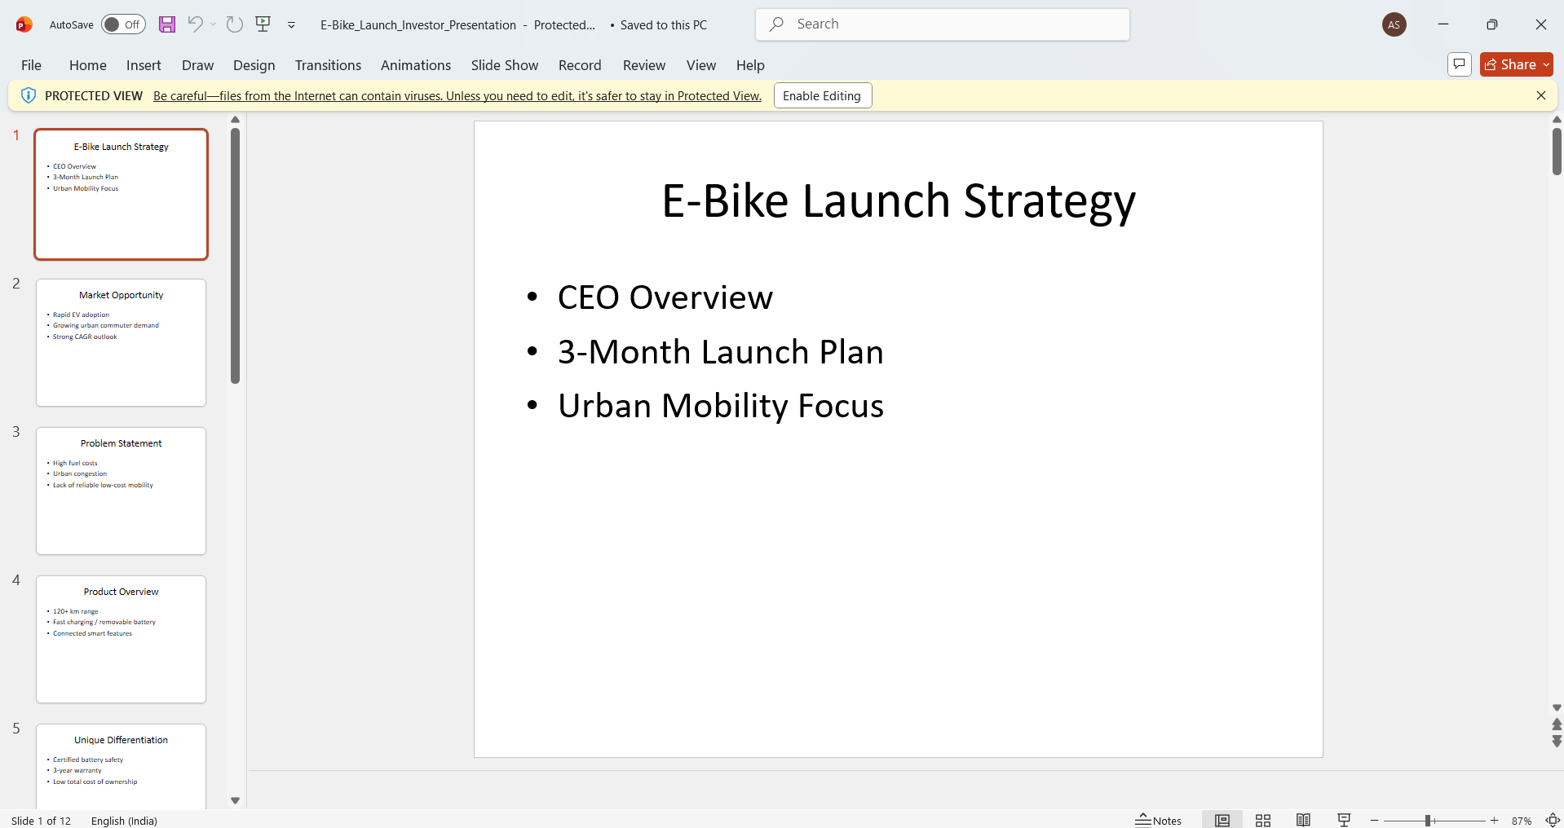

E-Bike_Financials_and_KPI_Dashboard
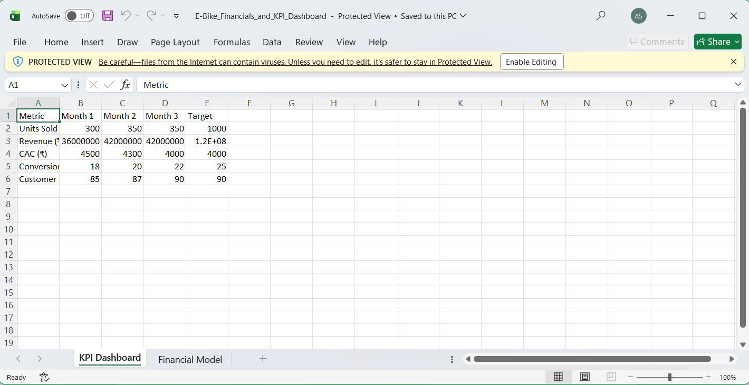

E-bike Launch Strategy Document

